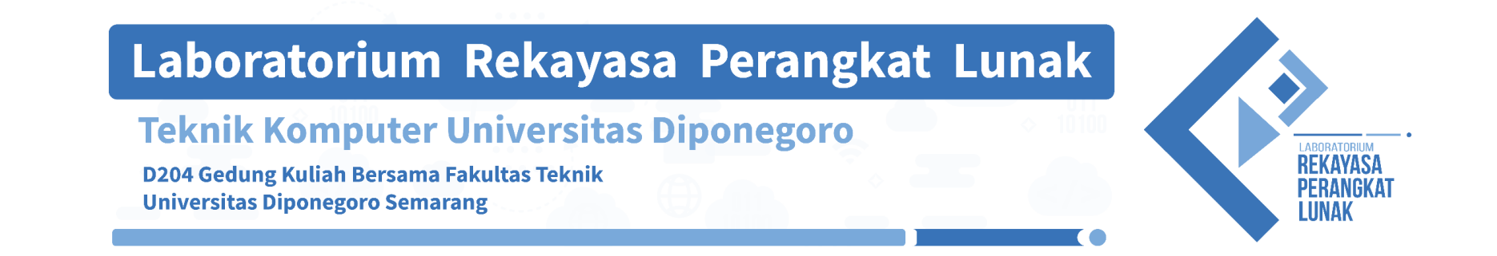**LEMBAR ASISTENSI TUGAS AKHIR**

PRAKTIKUM SISTEM BASIS DATA 2020

Foto

Judul Tugas Akhir : Sistem Sewa Bus

Nama Praktikan : Aldy Sufriyanto (21120118120021)

Nama Asisten : Muslim (21120117140032)

|  |  |  |  |  |
| --- | --- | --- | --- | --- |
| **No.** | **Hari/ Tanggal** | **Jenis Asistensi** | **Keterangan** | **TTD** |
| 1. | Rabu, 25/11/2020 | Asistensi ERD | AC |  |
| 2. | Rabu, 02/11/2020 | Asistensi program | ACC |  |
| 3. |  |  |  |  |
| 4. |  |  |  |  |



Mengetahui,

Koordinator Praktikum

Wahyu Aji Sulaiman.

21120117140019